|  |  |
| --- | --- |
| PROJECT ANALYSIS  Week 3 Assignment | ABSTRACT  This document was created for UMUC Course, CMSC 495, and analyzes aspects of the (TNC)  Group 3 Members  Name: Christiano, Andrew  Name: Fernandez, Yrume  Name: Orwick, Brian  Name: Sell, Julia  Class: CMSC 495 - Current Trends and Projects in Computer Science Professor: Dr. Hung Dao  Due: 10 September 2018 |

**Version Control**

|  |  |  |  |  |
| --- | --- | --- | --- | --- |
| Revision # | Date | Name | Descriptions | Contact Info |
| TNC_0001 | 9/4/2018 | Brian Orwick | Created | Orwick12@outlook.com |
| TNC_0002 | 9/6/18 | Brian Orwick |  |  |
|  |  |  |  |  |

**Table of Contents**

1. **Outside Systems**
2. **Input Data**
3. **Output Data**
4. **Data Processing**
5. **Subsystem Requirements**
6. **Data Interface**
7. **Potential Risk and Mitigation**
8. **Future Enhancements**

**Outside Systems**

* User

**Input Data**

* News source websites (Fox News, USA Today)
* Trustworthy Rating (user based)

**Output Data**

* Trustworthy rating (user based, rotten tomatoes)
* Trustworthy rating (amount of times article is posted)
* ???? Tables or charts showing trustworthy breakdowns?????

**Data Processing**

* User will go to TNC website
* TNC database will request scraping articles from news sources and search for similar articles to determine how many times it has been posted to adjust a rating number and assign it to that article
  + This will ensure the same article is not posted several times
* User can also vote on the trustworthiness of the article which will then determine a rating number based on all users votes

**Subsystem Requirements**

* Database
* HTML Interface
* Scraper
* Article comparator

**Subsystem Diagram with inputs**

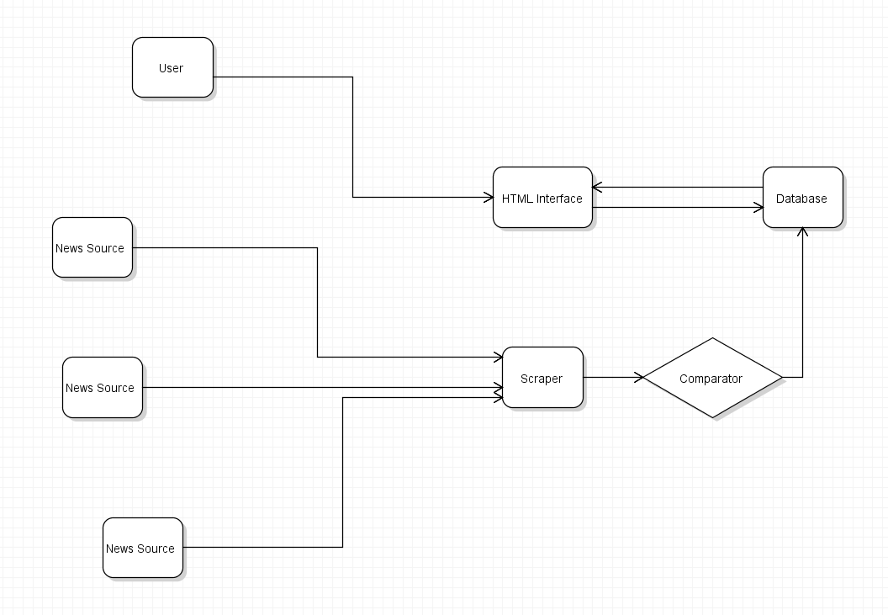

**Data Interface**

* Both Trustworthy ratings will be next to the title ???and summary??? of the article
* Trustworthy ratings on charts are shown on another page to show which news sites have the highest trustworthy settings

**Potential Risks**

* While scraping if a source changes any of the HTML to their site it could destroy scraping for that site, while drastic error, relatively quick fix to adjust scraper

**Future Enhancements**

* Add more news sources
* Utilize news website API’s
* More data breakdown
* User login, track user data